

Predicting the Size of a Forest Fire using Deep Learning Techniques

MSc Research Project

Data Analytics

Amit Sahoo

X18188851

School of Computing

National College of Ireland

Supervisor: Dr. Catherine Mulwa

National College of Ireland

MSc Project Submission Sheet

School of Computing
Student Name: | Mr Amit Kumar Sahoo
Student ID: | X18188851
Programme: | Data Analytics | Year: | 2019-2020
Module: | MSc Research Project
Supervisor: | Dr. Catherine Mulwa
Submission Due Date: | 17th August 2020
Project Title: | Predicting the size of a forest fire using deep learning techniques
Word Count: | 20 Page Count 15000 words

I hereby certify that the information contained in this (my submission) is information pertaining to research I conducted for this project. All information other than my own contribution will be fully referenced and listed in the relevant bibliography section at the rear of the project.
ALL internet material must be referenced in the bibliography section. Students are required to use the Referencing Standard specified in the report template. To use other author's written or electronic work is illegal (plagiarism) and may result in disciplinary action.
Signature: | Amit Kumar Sahoo
Date: | 17th August 2020

PLEASE READ THE FOLLOWING INSTRUCTIONS AND CHECKLIST

Attach a completed copy of this sheet to each project (including multiple copies) | □
Attach a Moodle submission receipt of the online project submission, to each project (including multiple copies). | □
You must ensure that you retain a HARD COPY of the project, both for your own reference and in case a project is lost or mislaid. It is not sufficient to keep a copy on computer. | □

Assignments that are submitted to the Programme Coordinator Office must be placed into the assignment box located outside the office.

Office Use Only
Signature:
Date:
Penalty Applied (if applicable):

Predicting the Size of a forest fire using deep learning techniques

Amit Sahoo

x18188851
MSc Research Project in Data Analytics
17th August 2020

Abstract
Abstract goes here. You should provide a high-level (approx. 150 - 250 words) overview of your paper, its motivation, and the core findings. This is the teaser of your work it'll probably be best to write it last.

Introduction

Various countries have been battling forest fires for a long time now. Such unfortunate incidents take place due to natural reasons like volcanic eruptions and lightning but mostly happens because of human activities such as unextinguished cigarette butts, fire camping, and garbage deposit burning. Such incidents have become quite frequent over the last few years. As a result, a lot of flora and fauna species are getting disappeared, natural habitat and food chains are getting imbalanced. It also emits a lot of carbon emission to the environment, which leads to a green-house effect and climate change, soil erosion. Therefore, it will be useful if the exact area that will be under the fire threat can be predicted.

Motivation and Project Background

A lot of studies have been carried out on this global problem, especially in the last few decades. The number of forest fires caused due to high voltage overhead electric powerlines in the Mediterranean forest has been explained in detail (Martinez-Canales, 1997) to prevent such incidents and minimize the loss due to it. Numerous studies have been done for detecting the fire. One of the early researches has been done by Cappellini et al. (Cappellini, Mattii, and Mecocci, 1989) where fire detection was done at the early stages with the help of TV cameras in real-time. These camera helps to detect smoke during the daytime and flames during the nighttime. One more study on the detection of fire incidents in the boreal forest of Alaska was done by Bourgeau et al. (Bourgeau-Chavez, Kasischke, and French, 1993) using ERS-1 C-VV SAR imagery. It also determined the appearance of the basis of elapsed time, geomorphology of the area under fire, and metrological parameters. A similar study for detecting the forest fire in the eastern region of Russia has been done by Kawano et al. (Kawano, Kudoh, and Makino, 1999) using multi-dimensional satellite images. The method is based on the three-dimension histogram of the fire category. Not only in the field of detection, but various studies have also been done on modeling and forecasting of the fire. The likelihood of severe fires is determined from fire indices which are extracted through ground and remote satellite observation. These indices are collected for a period of 7years and are interpolated across various grids of The United States to determine the density of the fire occurrence (Minardi, Marchisio and Treder, 1999). A detailed study on the type of land and the extent of the forest fire has been done on the 1997 Indonesian fire. Detailed information about the land cover was derived by comparing the land cover maps with SPOT satellite images. After superimposing the burn scar on a digitized land cover, it was evident that fire has occurred mostly on easily accessible areas such as agricultural lands and plantation areas(Lee et al., 1999). Surveys were conducted to better understand the effect of fire and the characteristics of the fire signatures with the help of three remote sensing systems operating in two different spectrums (French, Kasischke and Bourgeau-Chavez, 1994).

A study on the field of forest fires is mainly concentrated on detecting the fire at an early stage, forecasting the frequency of the fire at some inaccessible areas, the effect of fires on the vegetation, or accurate measurement of the burn scar. However, information about the scale of the forest fires from the first day of reported fire incident based on the meteorological details of the past few days and the readiness of the fire department on that day has not been explored much. Accurately predicting the size of the forest fire at an early stage will help the firefighting team to strategize fire extinguishing operations, positioning the crew member and equipment in the best possible position. This will reduce the spread of the fire and help in saving the life of the local people and the firefighters deployed on the site. This research will also help the local governing body to formulate rescue or evacuation operations for the people under the possible threat of fire. This will assist in granting permission to carry out the local business at the fire vicinity and restrict the tourist from entering the fire zone. This will also help in speculating the possible amount of carbon emission into the environment.

In ( 10.1007/s13762-017-1371-6) Geographical information system(GIS) is integrated with Evidential Belief Function(EBF) to determine probability of wildfire . Factors like topology, soil type, meteorological factors were taken as an input to this model. Based on the derived probability, areas were classified into moderate, high, and very high zones. In (Wotton and Martell, 2005) logistic regression has been used to find the probability that lightning would cause a sustainable ignition as well as the probability of the ignition being detected by the firefighting department. Predictors such as historical lightning strikes, fire weather/occurrence have been used. Since most of the fires are caused by humans, a logistic generalized additive model is designed to find out the probability of ignition at a 1km2 grid. Meteorological factors and socio-economic factors were used as the independent variables(Vilar et al., 2010). Forest department in few countries uses National Forest Fire Danger Rating System(NFFDRS) for predicting the severity of the fire. Among all, the Canadian NFFRDS(CFFRDS) has been widely accepted across the globe in terms of reliability and consistency.

For the last few years, there has been a lot of studies conducted on this field using machine learning and especially Deep Learning. Deep learning has been proved to be better in terms of accuracy when dealing with a huge amount of data for training and validation. The traditional machine learning models used for forest fire size predictions cannot process datasets with huge size and numerous features. Research by Safi and Bouroumi (Safi, Bouroumi and Bouroumi, 2011) was one of the oldest studies where the Neural network approach is applied in predicting the size of the forest fire. The values of the hyperparameters are determined heuristically. Deep neural network models such as LSTM(Long short-term memory) has been used to predict the size of the fire at the beginning of its occurrence. This model has been implemented as a time series data and it was able to predict the occurrence trends with an accuracy of 90.9% (Liang, Zhang and Wang, 2019). In this research, we have taken a step further in predicting the size of the wildfire by using the time series data of meteorological parameters such as temperature, relative humidity, wind speed, precipitation, visibility, due point, sea level pressure and build a time series forecasting model with Convolutional Neural Network.

Research Question

RQ - “How well deep learning techniques (CNN with time-series, LSTM, RNN, ANN, ARIMA) can predict the size of a forest fire from its initial outbreak, based on weather details such as mean temperature, mean sea level pressure, mean dew point, total precipitation, visibility, mean wind speed, maximum sustained wind gust and the preparedness level by the firefighting department for each of the incident?”.
Prediction of forest fire is helpful for the local governing bodies and the fire-fighting department so that adequate resources can be arranged before it gets too difficult to handle such untoward incidents.

Sub RQ - ”How well CNN works for time-series data as compared to the convolutional LSTM model for time series forecasting? ”

Research Objective

Obj1: Critical review of the literature on prediction of forest fire/wildfire (2005-2020)
Obj2: Extracting the weather details of the day when the fire outbreak was noticed as well as four days before that date.

Obj 3 Prediction modelling of size of fire
Obj3(a): Implement, evaluate results of Convolutional Neural Network for time series forecasting
Obj3(b): Implement, evaluate results of LSTM(Long Short-Term Memory)
Obj2(d): Implement, evaluate results of Artificial neural network
Obj2(e): Implement, evaluate, results of ARIMA

Obj4: Comparison of developed methods (obj3)
Obj5: comparison of developed models (obj3) with other existing models

Section 2 provides a detailed study of the literature review on this field of study using fire indices and machine learning with different algorithms. Based on the findings from the previous section, Section-3 provides a methodology that has been used for this research. The Implementation of the project along with the prerequisite, pre-processing, and model selection is done in section 4. Section 5 explains the comparison of all the models used in the previous section and quantifies each model's performance based on a few evaluation parameters. Section 6 concludes this paper with the scope of future works.

Literature Review on size of Forest Fire Prediction and Identified Gaps
In this section, we investigate few of the already used models/techniques for predicting the size of a forest fire from its initial outbreak. This section is further divided into subsections i.e. (i) correlation between weather and wildfire occurrence (ii) predicting the size of a forest fire from fire indices (iii) use of machine learning in predicting the forest fire size (iv) use of neural network in predicting the size of the forest fire (iv) use of Convolutional Neural Network for time series forecasting (v) comparison among the models in terms of evaluation parameters.

Correlation between weather and wildfires occurrence.
A lot of research has been done to prove that wildfires and climate are highly correlated. In (Koutsias et al., 2013) a long-term association was proved between fire and weather by analysing the data which spans over period of more than a century(1984-2010). The analysis revealed that a statistically significant growth in fire occurrences have occurred after 1970. The number of fire occurrences is highly correlated with maximum air temperature and negatively correlated with precipitation. Thus, it establishes the fact that weather has a profound effect on the fire spread by directly controlling fuel moisture.

Predicting the size of a forest fire from fire indices.
The Canadian Fire Weather Index (FWI) is one the most popular and widely used tool to predict the severity of a fire hazard. It is one of the subsystems of Canadian Forest Fire danger(CFFDRS). FWI provides information on fire weather information, fuel moisture codes and fire behaviour indexes(Vetrita et al., 2012). In the paper (Chelli et al., 2015) an adaption of FWI is proposed by taking into account Mediterranean vegetation and climate. The indexes are measured by fitting the collected data on fuel moisture content and the other values as per the expected inputs for Canadian FWI. The results obtained, can describe the fuel moisture dynamics despite small sample areas and time constraint for data collection. Another such index used for fire danger estimation is McArthur Forest Fire Danger Index(FFDI). This Index cannot be used in few regions due to unavailability of instrument and human resource. This index is modified by introducing Normalized Multi-brand Drought Index(NMDI) and achieved an overall accuracy of 82% (Suresh Babu et al., 2017). Various fire danger rating system are being used in different part of the world, FFDI(McArthur et al. 1967)is Australia, Forest Fire Behaviour Table(FFBT) in western Australia (Beggs, 1976), FWI in Canada(Wagner, 1987), National Fire Danger Rating System(NFDRS) in USA(Bradshaw et al., 1984) and Nesterov Fire Danger Index System in the Russia(V. G Nesterov, 1949). Most of these fire danger rating system uses only uses four weather parameters such as temperature, relative humidity, precipitation, and wind speed. However other factors such topography and fuel properties, preparedness level of the fire-fighting department is assumed to be constant. Few of the other fire rating system uses ground data on a regular basis, which is not feasible all the time. Using machine learning techniques to tackle such problems can be a better solution.

Use of machine learning in predicting the forest fire size
Various machine learning algorithms for classifying a fire or a no-fire such as Logistic regression, Support Vector machine(SVM), Decision Tree, Random forest have been discussed (Molovtsev and Sineva, 2019) using a one of the most popular data source present in UCI repository (Forest Fires Data Set,) i.e. data from The National park of Monteshino located in northern part of Portugal. All these models for binary classification were evaluated with the help of a confusion matrix. Random forest algorithm proved to be superior among all of the other models with respect to Recall, Precision, F1, Accuracy. On the same dataset, the prediction on the fire size is also done(Cortez and Morais, 2007) using various data mining techniques such as Multiple Regression, Decision Tree, Random Forest, Neural Network and SVM on four different features i.e spatial , temporal, FWI components, weather attributes. Low-cost real-time data was used instead of the satellite and scanner approaches. SVM proved to be the best among all other data mining techniques in terms of MAD, RMSE and REC curve. However, the model has a very low predictive accuracy for large fires(> 1 hectare).
Linear regression, which is considered to be the most simple machine learning technique in predicting the size of the forest fire with taking the area burnt as a dependent variable and the meteorological factors as predictor (Afifuddin et al., 2019). Predictors such as hight temperature and low humidity are fund to be statistically significant in finding the exact amount of area burnt. A pattern analysis is also performed in the same research with shows that each year with reported fire incidents is followed by two years of fire outbreak. However global average temperature increases every year as result of interaction effects with other climatic components(Zhang, 2018). A multi-variate time series analysis would be a better choice in revealing the mechanism of climate change and its consequences as it captures temporal features and historical dependencies.

Use of Neural Network in predicting the forest fire size
With the advancement of Neural network over the last decade, the application can be seen even in the field of natural disasters. Detection of forest fire have been done by Novac(Novac et al., 2020) through a RGB-D enabled quadcopter which moves in a snake like pattern and sweeps the targeted area. Once it senses the fire, it extracts the blob and the same is then fed to a Deep Convolution Neural Network(DCNN). However, with this technique, only detection for fire can be done not much data can be extracted for the prediction of the fire size. Feed forward Neural network technique had been applied in predicting the size of a forest fire in Monteshino Natural Park, Portugal(Safi and Bouroumi, 2013). Hyperparameter such as number of neurons in a layer and the number of hidden layers is determined heuristically. After a lot of hyperparameter fine-tuning, the architecture was finalized with one hidden layer, 36 neurons and 10,000 iteration. Since optimizing such hyperparameters can take a lot of effort and calculation, a different approach was applied by Anshori (Anshori et al., 2019) called Extreme learning machine(ELM) which removed the way of learning from a slow gradient based algorithm as well as the repetitive task of hyperparameter tuning. This technique uses a single hidden layer and is more stable in terms of accuracy and relatively faster in computation as compared to neural networks with back propagation. ELM training includes a number of steps like initializing weights and bias, determining the output from the hidden layer, applying the required activation function, calculating the Moore-Penrose Pseudo Inverse Matrix, deriving the output weights and then the predicted results. This technique not only gave an RMSE value of 63.09 but also took 25.9ms to execute.
One of the research by Liang (Liang, Zhang and Wang, 2019) is done on the dataset collected from Canada National Fire Database(CNFDB) containing the wildfire and meteorological data for Alberta, Canada. Multi-collinearity and feature normalization id done to the data and then fed to various deep learning models such as Backpropagation neural network(BPNN), Recurrent neural network(RNN) and long-short term memory(LSTM) for predicting the fire size. LSTM showed the best accuracy rate of 90.9%. However, LSTMs is time consuming, need more memory to train, easy to overfit, regularization through drop out is difficult to implement and very sensitive to different random weights initializations. All these drawback of LSTM gives birth to a simple model like 1D conv net(1D-CNN) which has been used in this research.

Use of Convolutional Neural Network for time series forecasting
For prediction, not only the history of input values needs to be considered, but also implicit influence factors need to be considered. In addition to the LSTM, CNN can be used for prediction in a multidimensional variable where it learns the horizontal relationship among the variables in a multivariate raw data. 1D CNN model is used to forecast short term rainfall(Patel, Patel and Ghosh, 2018). The usage of 1D CNN for time series analysis has been explored recently. Architecture developed in CNN can run at almost half of the trainable parameters compared to the architecture developed by LSTM. This make CNN a better choice when the size of the dataset is too small for a LSTM.

Research Methodology

Introduction
A data mining research is usually carried out in either KDD(Knowledge Discovery in Databases), SEMMA(Sample, Explore, Modify, Model, Access) or CRISP-DM(Cross-Industry Standard Process for Data Mining) methodology. KDD method has been used in this research it as it extracts what is deemed knowledge using a selected dataset with pre-processing, transformation, data mining, and evaluation, whereas SEEMA doesn’t focuses much on data specific task and is applied to general data science task and CRISP DM focuses on understanding the objective from a business perspective, and the converts this knowledge into data mining problem designs a preliminary plan to achieve those objective(Azevedo and Santos, 2008).

Modified KDD and Data Mining Methodologies
This modified KDD methodology for predicting the size of the forest fire consists of following stages (i) data selection for forest fire in xls format from Alaska Interagency Coordination Center (AICC) (ii) data selection for historic weather details for the day in which the fire incident takes place and the previous 4 days from The Old Farmer’s Almanac¹(https://www.almanac.com/weather/history/AK) in form of xls with the help of Python libraries such Selenium, Beautifulsoup and a robotic process automation tool called as UIPath. (iii) pre-processing, EDA and normalizing the input vectors (iv) models such as CNN, LSTM, RNN, Decision tree, SVM are trained on this data (v) Models were evaluated based on their accuracy as a measure.

Data Preparation Process Flow
The data creation process(depicted in Fig1) consists of the following steps: (i) downloading the fire data from AICC which contains the number of fire occurred, total area impacted, preparedness level and the date in which the fire incident was reported in form of an xls. (ii) This fire reported date is used to get the weather details from The Old Farmer’s Almanac website for that particular date as well as the previous four days (iii) the data is extracted(as a xls file) with python libraries such as Beautifulsoup, Selenium, and a tool for robotic process automation called as UIPath (iv) python libraries for extraction of data is done in separate instances created in AWS cloud platform, because it is a very time consuming process and had to be executed in parallel systems.(v) the extracted weather data is finally merged with the fire data to obtain the final dataset for this research.
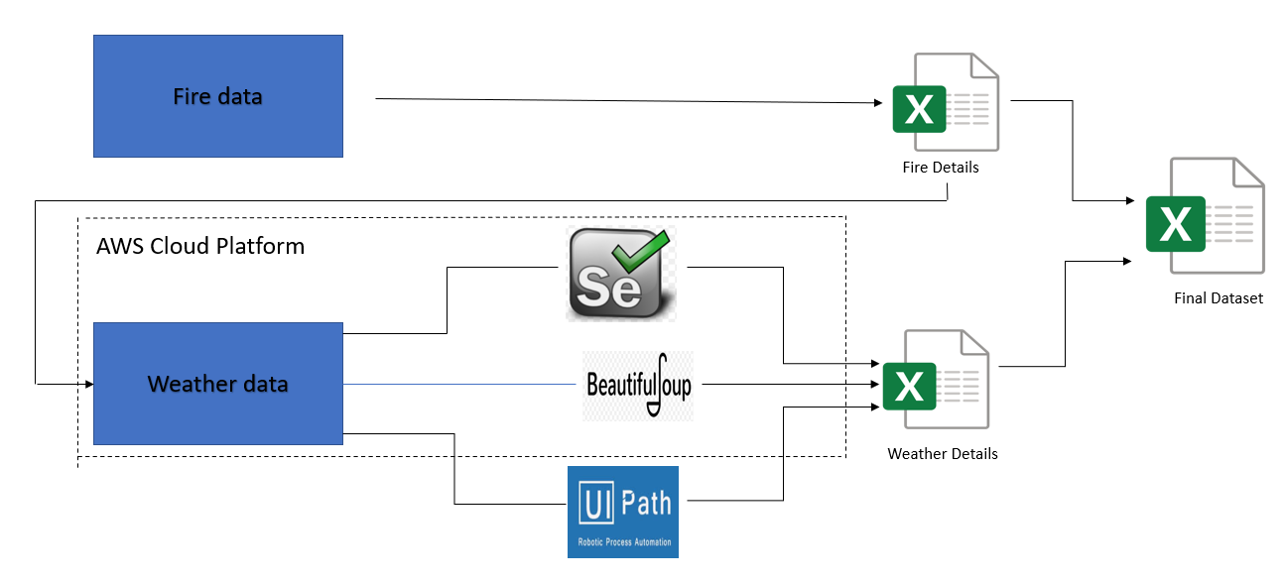
Fig 1- Data Creation Process flow

Project Design Process Flow
The Project design phase(Depicted in Fig 2) consists of two layers (i) Presentation layer (ii) Business layer. In presentation layer various visualization are done using Tableau, Python, R. In business layer, explanatory analysis, feature engineering, feature selection and feature reduction has been implemented using various predefined packages and few custom functions in Python and R. Various Machine Learning and Deep Learning models have been built on the extracted features and evaluated through some predefined parameters.

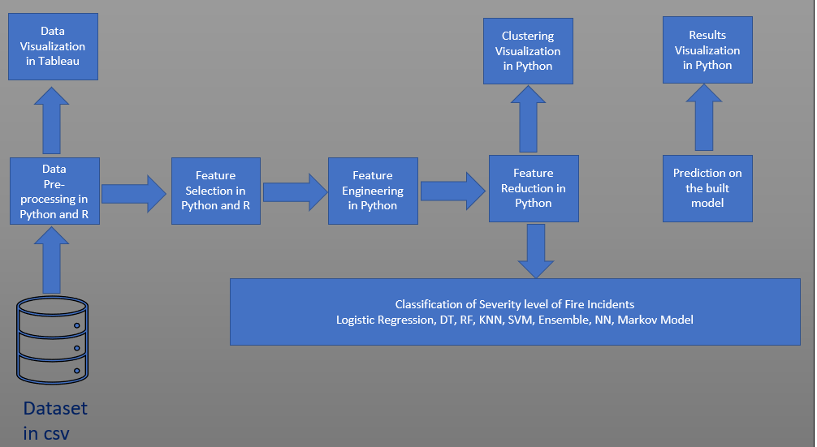
Figure 2: Project Design process flow

Conclusion
Traditional KDD methodology has been modified as per the problem statement and requirement. Data has been collected from multiple sources and merged to build the final dataset. Explanatory analysis has been performed in the final dataset to provide few insights about the data. Implementation, evaluation, and a critical comparison of the results has been done in the next section.

Implementation, Evaluation and Results of Forest Fire Severity classification models

Introduction
This sections provides a detailed description on the process of building the dataset for this research, its initial pre-processing, methods for selecting the important features, checking the distribution of the variables used, transforming it into minimal components, training the data on various machine learning models, and comparing all the used models using confusion matrix and determining the Accuracy, Precision, Recall and F1-score. At the final stage, the model with best evaluating parameters is selected.

Business Understanding
The first intuitive factor behind a forest fire is Temperature. However, temperature of the day of the incident does not give sufficient information, however a sequence of the temperature before the day of the fire gives more intuition. Similarly, other factors such precipitation, wind speed, dew point, visibility can combine to give a better understanding of the severity of fire. Therefore, all these parameters were collected for the day of the fire incident(Day-0) and the previous four days(Day-1.Day-2,Day-3,Day-4).

Data Acquisition

Fire Incidents have been collected from Alaska Interagency Coordination Centre – Alaska Daily Stats Report, which contains the details of fire incident from 1993 to 2019 with date of incident , total number of fires(cumulative over an year) , total acres of area burnt(cumulative over an year), preparedness level of the Fire Department on the scale of 1-5, where 5 is assumed to be the best preparedness level and 1- worst preparedness level, total number of fire incidents occurred due to human activities and lightening and their corresponding acres of area burnt. Analysis on classification of fire based on its reason(human activities or lightening) has been kept out of the scope for this research, thus related columns are dropped. Columns that are considered for this research are:- ‘ID’,’FireSeason’,’Month’,’Day’,’SitReportDate’,’TotalFires’, TotalAcres’, ‘PrepLevel’.

Historical weather data has been collected from ‘THE OLD FARMER’S ALMANAC’ website which contains historical weather data for USA and Canada. The inputs that needs to be provided for extracting the weather details are – (i) Area name (ii)date in the form of YYYY-MON-DD. The same details are also present in the url of the resultant page. Akiachak area has been chosen for this research, and dates are selected from the fire incident data. URLs were created for scrapping the data for the fire incident day, as well as 4days prior to it. With the help of some third-party tools such as UIPath, and few predefined packages in Python, an automated system was designed so that system will browse all the given urls and extract the meteorological details such as minimum temperature in Fahrenheit(F), mean temperature(F), maximum(F),mean sea level pressure in Inches of Mercury(IN), Mean due point(F), Total precipitation(IN), visibility in Miles(MI), Mean wind speed in miles per hour(MPH), maximum sustained wind speed(MPH), maximum wind gust(MPH). All these details were extracted for the reported day for fire incident(Day0) and four days prior to the same day (Day-1,Day-2,Day-3,Day-4).
Table- Dataset Description
Dataset | Record Count | Attribute count
Fire Dataset | 3264 | 08
Day-0 Weather data | 3264 | 10
Day-1 Weather data | 3264 | 10
Day-2 Weather data | 3264 | 10
Day-3 Weather data | 3264 | 10
Day-4 Weather data | 3264 | 10

Data Pre-Processing

Data Merging
Once the dataset is extracted for all five days, the next step is to merge them all based on date. The same has been depicted in Fig 3. In this case, the number of fire incidents and the total acres burnt are cumulative over a year. Thus, for simplicity, the cumulative numbers were converted into individual numbers. Further few duplicate records were removed from the dataset. Therefore, number of records in the dataset got reduced from 3264 to 3249.
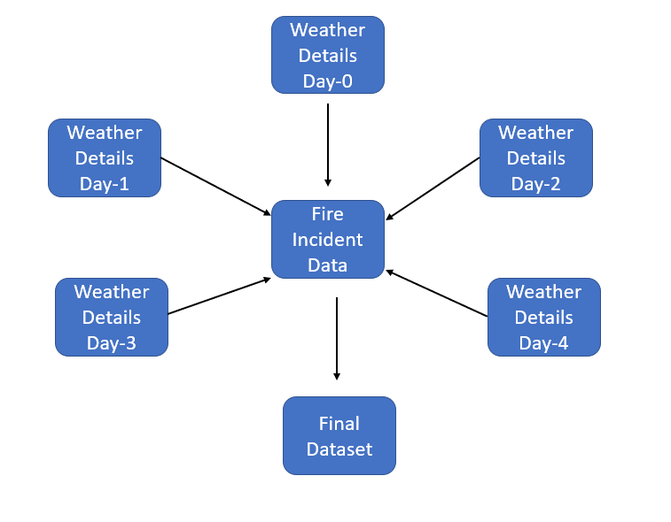

Handling of Missing values

Missing values is the first obstacle that needs to be dealt before building any model in machine learning. All missiing values in this dataset were checked to find out the percentage of data missing for every column(whichever have atleast one missing value). Figure4 depicts the same information in the a form a of bar chart.

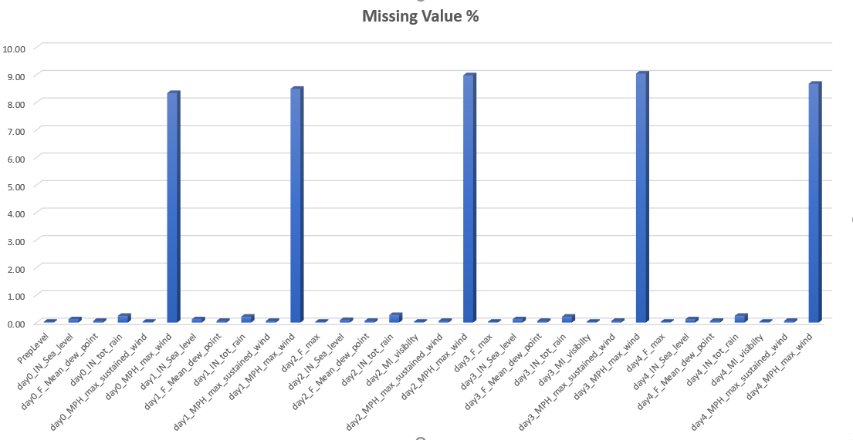
Upon checking the distribution of the various attributes, it was observed that Maximum wind gust for the all 5days(Day0, Day-1, Day-2, Day-3,day-4) had a garbage value(can be considered as outlier) of 999MPH which constitute 33% of the whole data. Figure 3 depicts the distribution of Maximum wind gust for all 5days. All these outliers were replaced by Null which is further imputed in the next stage. There is no influential outlier in the remaining data. The same has been checked through box plot for all the features.

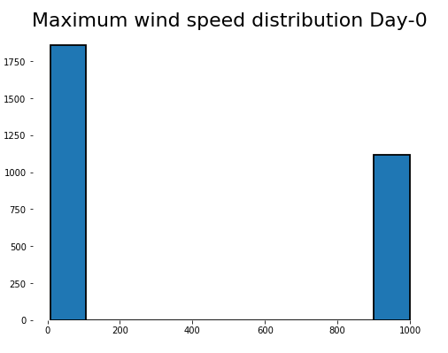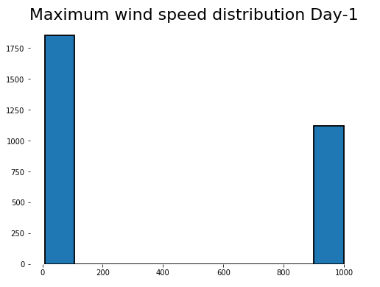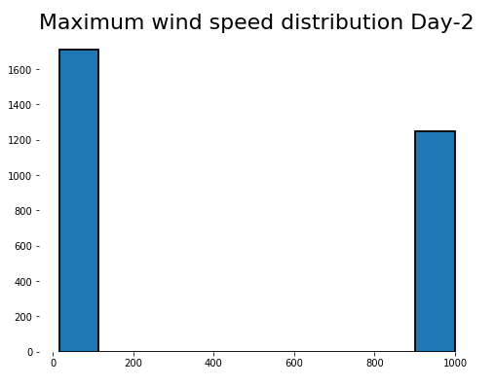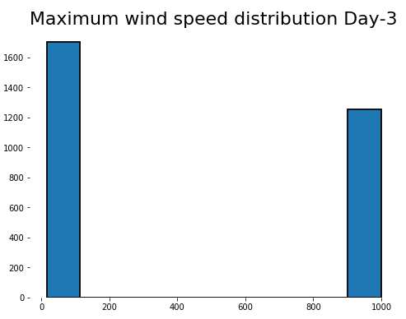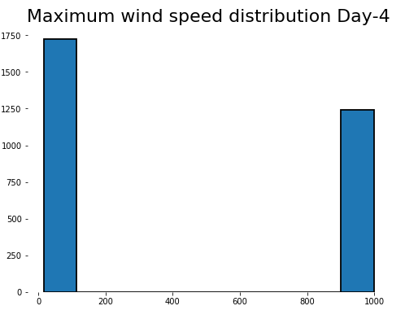

A package knowns as MICE(Multivariate Imputation via Chained Equation) in R as been used to impute the missing values as it creates multiple imputation as compared to the single imputation by mean. It imputes the missing value in an column on the basis of other observed values and an imputation model(default is Predictive Mean Matching for numerical varables and Multinomial Logistic regression). This package generated three different datasets which is only different in missing values. The dataset whose column mean is closest to the corrosponding original observed column has been considered to be the final dataset. Fig5 represent the missing values in a column in red while the observed values in blue . First block(row-1,column-1) represents the original datset, while the other blocks represents the imputed values in different datasets generated through MICE.

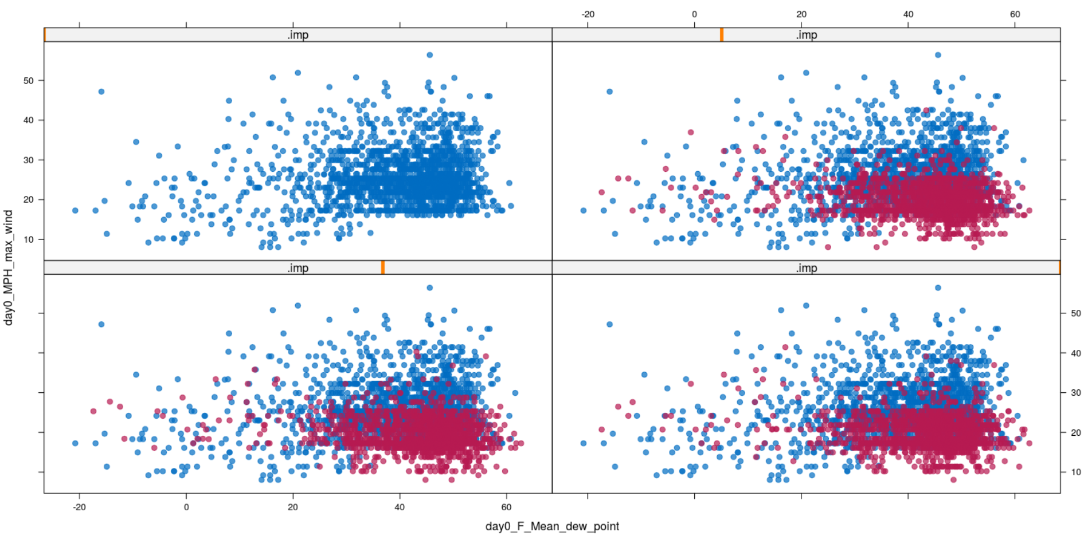

Feature Engineering
The final dataset contains both numerical and categorical values and each require a different kind of treatment before applying machine learning models to train. Below are the few feature engineering techniques applied on this dataset.

One-Hot Encoding
Categorical values present in the dataset are Month, Year while Preparedness level for fire fighters is an ordinal data. One hot encoding has been applied to all the nominal and ordinal data, to transform each category to a different feature resulting a binary transformation of 0 and 1. For example, month column has different values (Jan – Dec), which are transformed to different columns with name ‘month_Jan’ and so on.

Feature Scaling
Numerical values in the dataset are in different scale, such as temperature feature is in Fahrenheit while visibility is in miles, precipitation is in inch, and wind speed is in miles per hour. All these measuring units are different, and so as the values. Machine learning algorithms only see numbers, where more significant numbers play a decisive role during training. Even Gradient-Descent in Neural Network converges faster in scaled data. Therefore, it is necessary to bring all the values into a common scale of 0-1. Normalization has not been performed for tree-based models such as XGBoost and Random Forest.

Logarithmic Scale Transformation
Data such as precipitation is highly skewed, with maximum of amount of rainfall only in few months and approximately zero in remaining months. In such scenarios data has been transformed to logarithmic scale to achieve a normal distribution.

Feature Selection
Feature selection plays an important role in machine learning as it selects only key features to train the model. It is not advisable to use all the available features to build an algorithm. Multiple features often contain noise, which reduces the model’s accuracy and complicates the computation. Thus, Feature selection eliminates data redundancy , avoid multi collinearity , thus improving the model’s accuracy and reduces complexity.

Pearson's Correlation Coefficient
Pearson’s Correlation Coefficient has been used to determine if there is any correlation between the weather data for the past five days and the fire incident data. Correlated columns are removed, and a Multiple linear model has been implemented in RapidMiner and evaluation parameters were checked.

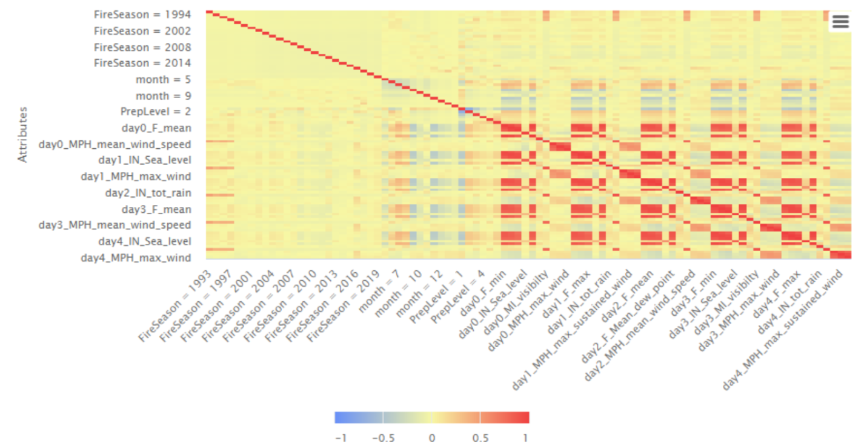

Boruta Selection Algorithm
This feature selection algorithm works as a wrapper algorithm on random Forest. It retains all the features which are relevant to the output variable. This algorithm fits a Random Forest model on the dataset and recursively get rid of the features that did not perform well in each iteration. Finally, the errors in random forest model minimizes which keeps only the minimal optimal subset of features. This algorithm has been applied in this dataset which retained 31 important features. The same is depicted in Figure6, were green features are relevant ones , while features in red can be removed.

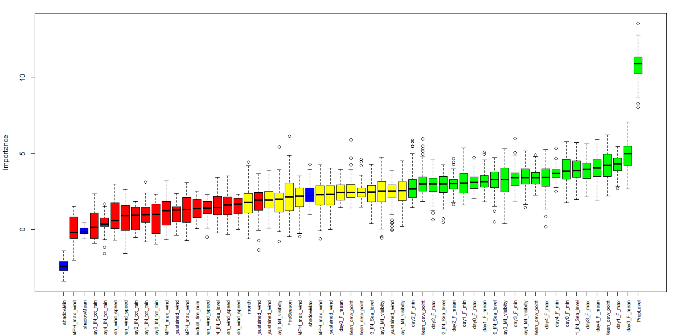

Recursive Feature Elimination
Recursive Feature Elimination(RFE) is one of the traditional Feature selections used in ML. This method has been used in the same dataset with random forest as the underlying algorithm(same as 4.4.4.2). However, this algorithm gives the highest weightage to variable day0_MPH_mean_wind_speed among all 51 available variables. Hence there is a need of better result for feature importance.

Random Forest Feature Selection
Random forest is one the embedded method used for Feature Selection which is combination of filter and wrapper methods(references). These kinds of feature selection are highly accurate, generalize better and interpretable. This algorithm creates multiple decision trees with random set of observations and features. The impurity is measured in Gini Index or Information Gain. While training a tree, the feature that decrease the impurity more, is considered to be more important and is averaged out across all tress to determine the importance of the variable. This algorithm chose only 9 features to be important. There are number of caveats that concerns the use of random forest selection algorithm. These includes concerns such as assignment of equal importance to corelated features and assigning preferences to high cardinality features. Another tree-based features selection algorithm called as LGBMClassifier(from the Python package - lightgbm ) derived 26 important features among the 51available features.

Conclusion
All the above Feature Selection are applied on the dataset and a multinomial Logistic Regression is built on the important features derived by each of the above discussed algorithm. Refer to the table 2 which shows the comparison among all the used algorithms and it is evident that Boruta Feature Selection works the best among them. Hence the features that are considered by the Boruta algorithms are finalized to build the model on.

Evaluation

The purpose of this section is to provide a comprehensive analysis of the results and main findings of the study as well as the implications of these finding both from academic and practitioner perspective are presented. Only the most relevant results that support your research question and objectives shall be presented. Provide an in-depth and rigorous analysis of the results. Statistical tools should be used to critically evaluate and assess the experimental research outputs and levels of significance.
Use visual aids such as graphs, charts, plots and so on to show the results.

Experiment / Case Study 1

. . .

Experiment / Case Study 2

. . .

Experiment / Case Study 3

. . .

Experiment / Case Study N

. . .

Discussion

A detailed discussion of the findings from the N experiments / case studies. Note that this discussion will have a lot more detail than the discussion in the following section (Conclusion). You should criticize the experiment(s), and be honest about whether your design was good enough. Suggest any modifications and improvements that could be made to the design to improve the results. You should always put your findings into the context of the previous research that you found during your literature review

Conclusion and Future Work

Restate your research question, your objectives and the work done. State how successful you have been in answering the research question and achieving the objectives. Restate the key findings. Discuss the implications of your research, talk about the efficacy of your research, and discuss its limitations.
Describe any proposals for future work or potential for commercialisation. Present MEANINGFUL future work. Sweeping more parameters in your simulation / model / platform is probably not meaningful. More discuss what could a follow up research project do, to better / differently approach / extend etc. your work.

References

Afifuddin et al. (2019) ‘Is Land and Forest Fire in Ogan Komering Ilir, Southern Sumatera, Affected by Climate Change?’, in 2019 IEEE Asia-Pacific Conference on Geoscience, Electronics and Remote Sensing Technology (AGERS). 2019 IEEE Asia-Pacific Conference on Geoscience, Electronics and Remote Sensing Technology (AGERS), pp. 95–98. doi: 10.1109/AGERS48446.2019.9034289.
Anshori, M. et al. (2019) ‘Prediction of Forest Fire using Neural Network based on Extreme Learning Machines (ELM)’, in 2019 International Conference on Sustainable Information Engineering and Technology (SIET). 2019 International Conference on Sustainable Information Engineering and Technology (SIET), pp. 301–305. doi: 10.1109/SIET48054.2019.8986106.
Azevedo, A. and Santos, M. (2008) ‘KDD, semma and CRISP-DM: A parallel overview’, in, pp. 182–185.
Beggs, B. J. (1976) Forest fire behaviour tables for Western Australia. Forest Dept., Western Australia. Available at: https://agris.fao.org/agris-search/search.do?recordID=US201300061773 (Accessed: 2 July 2020).
Bourgeau-Chavez, L. L., Kasischke, E. S. and French, N. H. F. (1993) ‘Detection And Interpretation Of Fire-disturbed Boreal Forest Ecosystems In Alaska Using Spacebarne SAR Data’, in Proceedings of IEEE Topical Symposium on Combined Optical, Microwave, Earth and Atmosphere Sensing. IEEE Topical Symposium on Combined Optical, Microwave, Earth and Atmosphere Sensing, Albuquerque, NM, USA: IEEE, pp. 236–239. doi: 10.1109/COMEAS.1993.700229.
Bradshaw, L. S. et al. (1984) The 1978 National Fire-Danger Rating System: technical documentation. INT-GTR-169. Ogden, UT: U.S. Department of Agriculture, Forest Service, Intermountain Forest and Range Experiment Station, p. INT-GTR-169. doi: 10.2737/INT-GTR-169.
Cappellini, V., Mattii, L. and Mecocci, A. (1989) ‘An intelligent system for automatic fire detection in forests’, in Cantoni, V. et al. (eds) Recent Issues in Pattern Analysis and Recognition. Berlin, Heidelberg: Springer Berlin Heidelberg (Lecture Notes in Computer Science), pp. 351–364. doi: 10.1007/3-540-51815-0_67.
Chelli, S. et al. (2015) ‘Adaptation of the Canadian Fire Weather Index to Mediterranean forests’, Natural Hazards, 75(2), pp. 1795–1810. doi: 10.1007/s11069-014-1397-8.
Cortez, P. and Morais, A. (2007) ‘A Data Mining Approach to Predict Forest Fires using Meteorological Data’.
French, N. H. F., Kasischke, E. S. and Bourgeau-Chavez, L. L. (1994) ‘Multi-sensor analysis of the effects of fire in the Alaskan boreal forest’, in Proceedings of National Aerospace and Electronics Conference (NAECON’94). Proceedings of National Aerospace and Electronics Conference (NAECON’94), pp. 1085–1089 vol.2. doi: 10.1109/NAECON.1994.332922.
Kawano, K., Kudoh, J. and Makino, S. (1999) ‘Forest fire detection in Far East region of Russia by using NOAA AVHRR images’, in IEEE 1999 International Geoscience and Remote Sensing Symposium. IGARSS’99 (Cat. No.99CH36293). IEEE 1999 International Geoscience and Remote Sensing Symposium. IGARSS’99, Hamburg, Germany: IEEE, pp. 858–860. doi: 10.1109/IGARSS.1999.774465.
Koutsias, N. et al. (2013) ‘On the relationships between forest fires and weather conditions in Greece from long-term national observations (1894–2010)’, International Journal of Wildland Fire, 22(4), p. 493. doi: 10.1071/WF12003.
Lee, G. et al. (1999) ‘Analysis of vegetation types affected by the 1997 forest fires in Sumatra’, in IEEE 1999 International Geoscience and Remote Sensing Symposium. IGARSS’99 (Cat. No.99CH36293). IEEE 1999 International Geoscience and Remote Sensing Symposium. IGARSS’99, Hamburg, Germany: IEEE, pp. 738–740. doi: 10.1109/IGARSS.1999.774424.
Liang, H., Zhang, M. and Wang, H. (2019) ‘A Neural Network Model for Wildfire Scale Prediction Using Meteorological Factors’, IEEE Access. IEEE Access, 7, pp. 176746–176755. doi: 10.1109/ACCESS.2019.2957837.
Martinez-Canales, J. F. (1997) ‘A review of the incidence of medium and high voltage overhead electric power lines in causing forest fires’, in 14th International Conference and Exhibition on Electricity Distribution (CIRED 1997 - Distributing Power for the Millennium). 14th International Conference and Exhibition on Electricity Distribution (CIRED 1997 - Distributing Power for the Millennium), Birmingham, UK: IEE, pp. v3-27-v3-27. doi: 10.1049/cp:19970533.
Minardi, J., Marchisio, G. B. and Treder, R. P. (1999) ‘Spatial linear modeling and forecasting of forest fires across the United States’, in IEEE 1999 International Geoscience and Remote Sensing Symposium. IGARSS’99 (Cat. No.99CH36293). IEEE 1999 International Geoscience and Remote Sensing Symposium. IGARSS’99, Hamburg, Germany: IEEE, pp. 861–863. doi: 10.1109/IGARSS.1999.774466.
Molovtsev, M. D. and Sineva, I. S. (2019) ‘Classification Algorithms Analysis in the Forest Fire Detection Problem’, in 2019 International Conference ‘Quality Management, Transport and Information Security, Information Technologies’ (IT&QM&IS). 2019 International Conference ‘Quality Management, Transport and Information Security, Information Technologies’ (IT&QM&IS), Sochi, Russia: IEEE, pp. 548–553. doi: 10.1109/ITQMIS.2019.8928398.
Novac, I. et al. (2020) ‘A Framework for Wildfire Inspection Using Deep Convolutional Neural Networks’, in 2020 IEEE/SICE International Symposium on System Integration (SII). 2020 IEEE/SICE International Symposium on System Integration (SII), pp. 867–872. doi: 10.1109/SII46433.2020.9026244.
Patel, M., Patel, A. and Ghosh, D. R. (no date) ‘Precipitation Nowcasting: Leveraging bidirectional LSTM and 1D CNN’, p. 7.
Safi, Y. and Bouroumi, A. (2013) ‘Prediction of forest fires using Artificial neural networks’, Applied Mathematical Sciences, 7, pp. 271–286. doi: 10.12988/ams.2013.13025.
Safi, Y., Bouroumi, A. and Bouroumi, A. (2011) ‘A neural network approach for predicting forest fires’, in 2011 International Conference on Multimedia Computing and Systems. 2011 International Conference on Multimedia Computing and Systems, pp. 1–5. doi: 10.1109/ICMCS.2011.5945716.
Suresh Babu, K. V. et al. (2017) ‘Assessment of forest fire danger using automatic weather stations and MODIS TERRA satellite datasets for the state Madhya Pradesh, India’, in 2017 International Conference on Advances in Computing, Communications and Informatics (ICACCI). 2017 International Conference on Advances in Computing, Communications and Informatics (ICACCI), pp. 1876–1881. doi: 10.1109/ICACCI.2017.8126118.
UCI Machine Learning Repository: Forest Fires Data Set (no date). Available at: http://archive.ics.uci.edu/ml/datasets/Forest+Fires (Accessed: 2 July 2020).
Vetrita, Y. et al. (2012) ‘Drought and fine fuel moisture code evaluation: An early warning system for forest/land fire using remote sensing approach’, International Journal of Remote Sensing and Earth Sciences, 9, pp. 140–147. doi: 10.30536/j.ijreses.2012.v9.a1841.
Vilar, L. et al. (2010) ‘A model for predicting human-caused wildfire occurrence in the region of Madrid, Spain’, International Journal of Wildland Fire, 19(3), p. 325. doi: 10.1071/WF09030.
Wagner, C. E. V. (1987) Development and structure of the Canadian Forest Fire Weather Index System. Available at: /paper/Development-and-structure-of-the-Canadian-Forest-Wagner/5145e78acc8fabac336cee7e51dc0c01ec7654e5 (Accessed: 2 July 2020).
Wotton, B. M. and Martell, D. L. (2005) ‘A lightning fire occurrence model for Ontario’, Canadian Journal of Forest Research, 35(6), pp. 1389–1401. doi: 10.1139/x05-071.
Zhang, Z. (2018) Multivariate Time Series Analysis in Climate and Environmental Research. doi: 10.1007/978-3-319-67340-0.

